Continuous Assessment Examination- 1 (Feb. 2022)
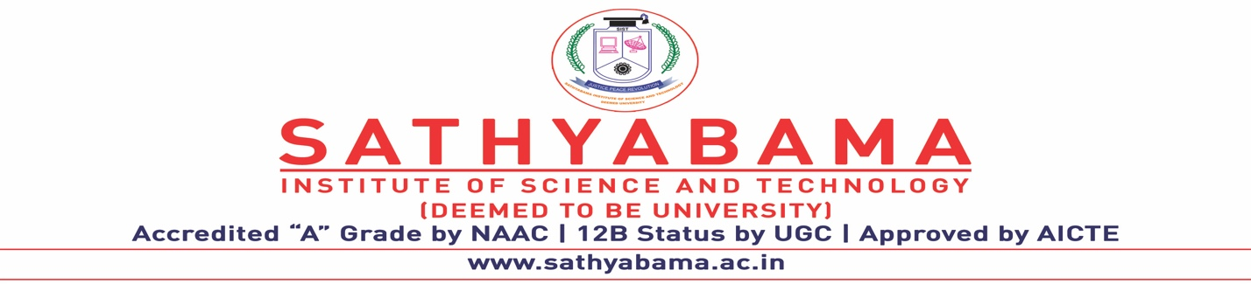
Program : All Programmes Max. Marks : 30
Course : B.E, B.TECH, BSC Time : 1 Hour
Course Code : SCSA3016 Sem : 4 & 6
Batch : CBCS Date : 04.02.2022
Part-A Answer ALL the questions (5×2=10)

Q.No | Questions | CO (L)
 | Illustrate the geometrical representation of a vector point. | CO1(L2)
 | Differentiate between matrices and tensors. | CO1(L2)
 | Find the mean, median, mode, and range for the following list of values: 1, 2, 4, 7 | CO1(L3)
 | When two vector will become perpendicular? | CO1(L2)
 | Enumerate the rank of a matrix with an example. | CO1(L2)
Part-B Answer ALL the questions (2×10=20)

Q.No | Questions | CO (L)
 | Calculate the pseudo inverse for the matrix B = 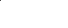 | CO1(L3)
 | (OR)
 | Find out the eigen values and eigen vectors for the given matrix 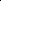 | CO1(L3)

 | Enumerate the different types of normal distributions | CO1(L2)
 | (OR)
 | Interpret Hypothesis testing and discuss how to test the assumptions made regarding a population parameter. | CO1(L2)

